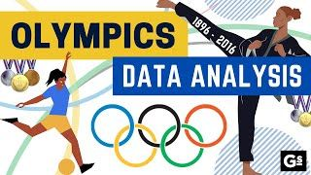
CAPSTONE PROJECT
-SPORTS ANALYTICS

SAISHA HEMRAJANI

-ACCIO JOBS
-DATA ANALYTICS
-CAPSTONE PROJECT

OVERVIEW


This dataset presents an extensive overview of athletic competitions, likely pertaining to the Olympic Games from 1896 to 2016, organized across several Excel sheets. It encompasses information regarding the games (ID, year, name, season), host cities, and individual athletes (name, gender, height, weight, age during the games). Furthermore, the dataset records event particulars (sport, event name), competitor performance and medal victories, along with the geographical and organizational affiliations of athletes (NOCs and regions). Overall, it is a rich resource for analysing trends in athlete demographics, competition outcomes, and global participation in sports.
This meticulously organized dataset enables thorough examination of diverse sporting trends. For example, one can readily monitor the progression of athlete demographics across various games, analysing shifts in average age, height, and weight for particular sports or genders. Additionally, it aids in comprehending the distribution of medals among regions and the performance of various NOCs over time. Moreover, the interconnected nature of the sheets allows for the exploration of the most successful sports at different games or the identification of top-performing athletes across numerous competitions.
This extensive perspective renders the dataset an essential resource for anyone keen on the history and statistics of significant athletic events.

DATA WORKFLOW PROCESS
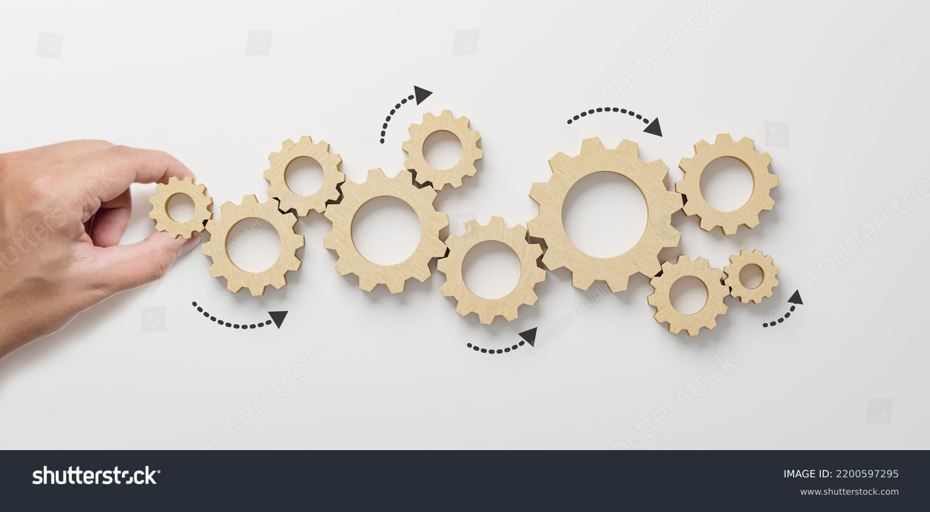
- Data gathering from GitHub
Obtained the required dataset from GitHub. Dataset contained 11 CSV files namely city, competitor- event, event, games, games-city, games competitor, medal, noc-region, region, person, person-region and sports.
- Data cleaning in MS-Excel
Checked the data for errors and inconsistencies, none were found.
- Data transformation
Altered the data into a format suitable for analysis, like changing category of columns from “general” to “text”, “number”, “currency” etc.
- Connecting with the appropriate tools
Established the connection between the dataset and appropriate tools. Downloading MS-Power BI for data visualization and downloading MYSQL Workbench for data analysis. Then, uploading the dataset into both tools.
- Exploratory Data Analysis (EDA)
Performed EDA questions using MS-Excel and SQL.
- Power BI Problem Statement Solution
Performed Power BI questions in MS-Power BI – report view function. Also, utilized DAX functions for easier data visualization.
- Data Visualization
Created a MS-PowerPoint Presentation to help better understand the data and present it in an engaging manner.
- Detailed Report/Documentation
Constructed a detailed report that accurately details the entire data workflow.
OBJECTIVE
The objective of this data analysis project is to carry out a comprehensive and systematic investigation of historical Olympic Games data (from 1896 to 2020) to uncover patterns, trends, and relationships across different dimensions of the Games. By utilizing structured data regarding athletes, events, sports, regions, and medals, the study aims to address key analytical questions related to participation, performance, and representation.
This research utilizes a combination of SQL-based queries, Excel, and Power BI visualizations for the analysis, with a strong emphasis on deriving insights that are both quantitatively rigorous and visually interpretable.
By utilizing organized data concerning athletes, events, sports, regions, and medals, the research seeks to answer significant analytical questions related to participation, performance, and representation.

SIGNIFICANCE
The dataset pertaining to the Olympic Games is of great importance, extending its relevance beyond academic research.
Its significance is derived from its ability to support decision-making, affect policy, and promote innovation in various sectors:
- Sports Analytics:
- Coaches and national sports organizations can evaluate historical trends to refine athlete training programs.
- Utilize patterns in age, height, weight, and event participation to discover promising athletes.
- Globalization and Geopolitics
- Participation and medal statistics demonstrate the global power dynamics and how nations convey soft power through sports.
- Analyzing the rise of emerging nations in Olympic success can be related to their economic or political progress.

DATA DICTIONARY
This project is based on Historical data on the modern Olympic Games, from Athens 1896 to Rio 2016.
In the context of the Olympic Games dataset, the dictionary is essential for analysts in comprehending the data fields, their interpretations, and their interrelations. This dataset comprises several relational tables that document information about athletes, events, medals, sports, regions, and editions of the Olympics.
1. City
Stores the names of host cities for Olympic Games.
Fields:
Column Name | Description
games_id | Foreign key referencing the Games table.
city_name | Name of the city that hosted the Olympic Games.

2. Games
Provides key details of each Olympic edition.
Fields:
Column Name | Description
games_id | Unique identifier for each Olympic edition.
games_year | The year in which the Games were held.
games_name | Official name of the Games (e.g., Tokyo 2020).
season | Indicates whether it is Summer or Winter Olympics.

3. Games_city
Links Olympic editions with host cities.
Fields:

Column Name | Description
games_id | Foreign key referencing Games table.
city_id | Foreign key referencing City table.

4. Sport
Defines the sports featured in the Olympics.
Fields:
Column Name | Description
sport_id | Unique identifier for each sport.
sport_name | Name of the sport (e.g., Athletics, Swimming).

5. event
Details about specific events under each sport.
Fields:
Column Name | Description
event_id | Unique identifier for the event.
sport_id | Foreign key linking to the Sport table.
event_name | Name of the event (e.g., 100m Men’s Final).

6. person
Contains demographic and physical details of athletes.
Fields:
Column Name | Description
person_id | Unique identifier for each athlete.
full_name | Athlete's full name.
gender | Athlete's gender (M or F).
height | Height in centimeters.
weight | Weight in kilograms.

7. games_competitor
Maps athletes to specific Olympic editions.
Fields:
Column Name | Description
games_competitor_id | Unique ID for the athlete’s participation.
games_id | Foreign key referencing the Games table.
person_id | Foreign key referencing the Person table.
age | Age of the athlete at the time of competition.

8. competitor_event
Tracks which competitors participated in which events and any medals won.
Fields:
Column Name | Description
event_id | Foreign key referencing the Event table.
competitor_id | Foreign key referencing the Games_Competitor table.
medal_id | Foreign key referencing the Medal table. (nullable if no medal was won)

9. medal
List of all types of medals.
Fields:
Column Name | Description
medal_id | Unique identifier for a medal.
medal_name | Type of medal: Gold, Silver, Bronze.

10. noc_region
Links National Olympic Committees (NOC) to their regions or countries.
Fields:
Column Name | Description
noc_region_id | Unique identifier for the region.
noc | National Olympic Committee code (e.g., USA, IND).
region_name | Name of the country or region.

11. person_region
Connects each athlete to their corresponding region.
Fields:
Column Name | Description
person_id | Foreign key referencing the Person table.
region_id | Foreign key referencing the NOC_Region table.

ER DIAGRAM
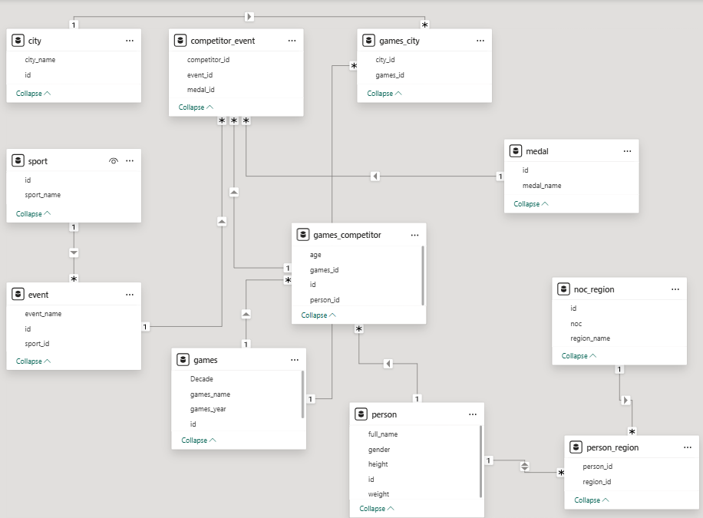
List of Joined Columns in MS- Power BI & SQL
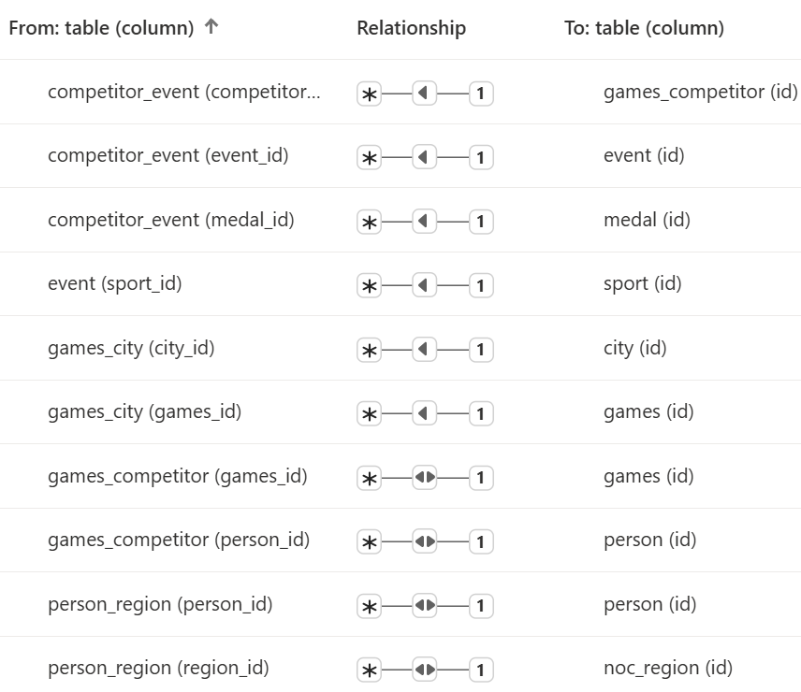
STEPS TO CONNECT TO THE DATASET
Steps to connect to the data using common tools like Power BI, MS- Excel, and MySQL Workbench, while the dataset is stored in MS- Excel:

- MS-Power BI
- Open Power BI Desktop.
- Click on “Get Data” > choose “Excel Workbook.”
- Browse and select “Sports_Analytics” dataset file.
- In the Navigator window, select all relevant sheets (e.g., games, sport, person, etc.).
- Click “Load” to import the tables.
- Use “Manage Relationships” to create links between tables using keys (e.g., games_id, sport_id, etc.).

- MySQL Workbench:
- Open MySQL Workbench and enter the root password.
- Connect to “MySQL Server” instance.
- Navigate to the "Server" menu and select "Data Import".
- Choose "Import from Self-Contained File" and select your CSV file.
- Select the target schema and table.
- Configure the import settings and start the import.
- Once, it finishes, check the rows number and then click on “Finish”

POWER BI PROBLEM STATEMENTS
- How many Olympic Games have been held in each season (Summer vs. Winter)?
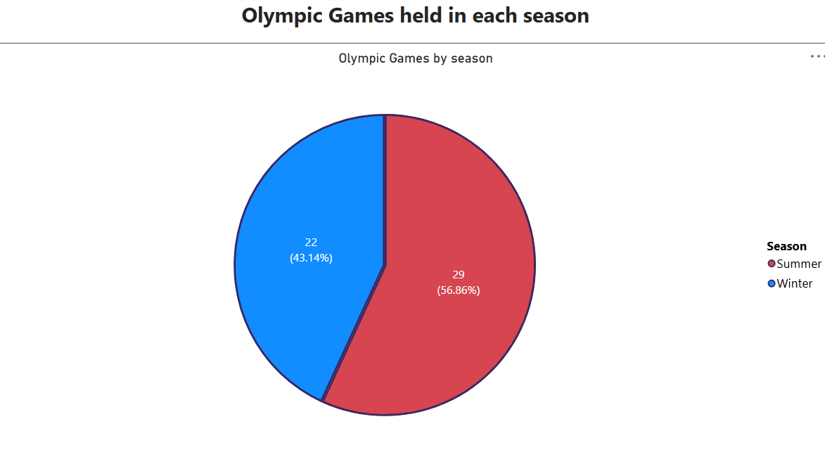
The pie-chart reveals that the Summer Olympics have been organized much more frequently than the Winter Olympics. This is in line with historical trends, as the Summer Games were initiated earlier (in 1896) and have a broader appeal worldwide, showcasing more sports and a larger number of athletes.
In contrast, the Winter Olympics began later (in 1924) and consist of sports that are restricted to colder climates, resulting in fewer iterations. This trend highlights the significance and ongoing relevance of the Summer Games in the global sporting arena.
- What is the distribution of games across different decades?
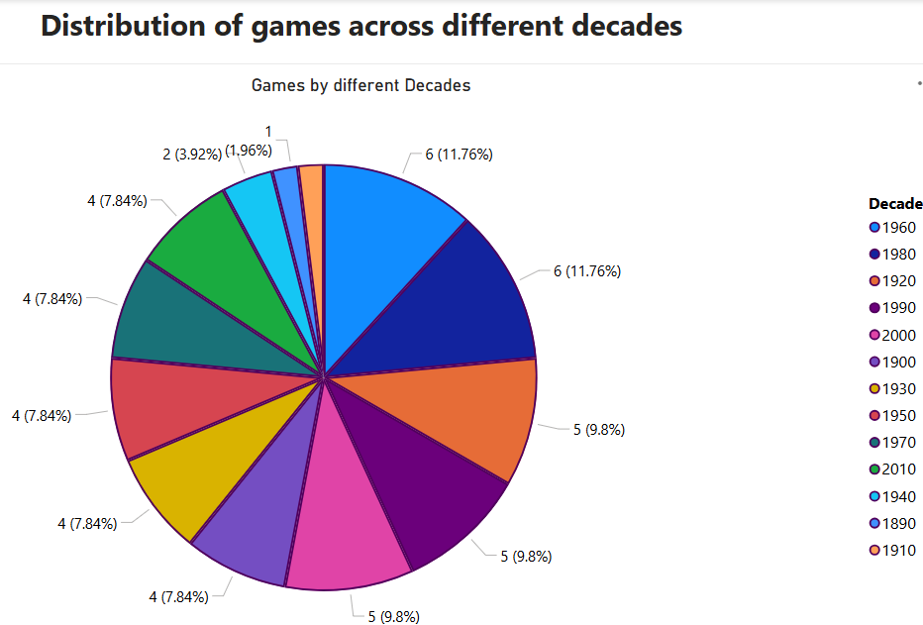
This pie-chart demonstrates a steady rise in the number of Olympic Games over the years, with significant gaps during the 1910s and 1940s due to World War I and World War II, which led to the cancellation of some editions. From the 1980s onward, the frequency became more regular, with both Summer and Winter Olympics occurring every four years.
The peak activity in the 1990s and 2000s illustrates the globalization of the Olympics and the growing participation of host countries.
This trend reflects both the historical interruptions and the current stability in the scheduling of the Games.

- Which cities have hosted the most Olympic Games?
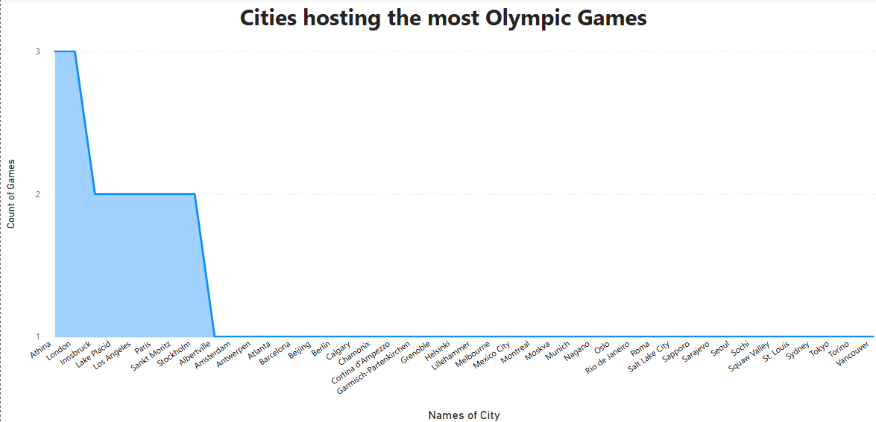
From the “Stacked Area Chart” it can be observed that only a few major cities have hosted the Olympic Games more than once, with London hosting three times (1908, 1948, 2012) along with Athena (1896,1906,2004). This trend also highlights the Olympics' preference for experienced host cities.
Cities like Innsbruck, Lake Placid, Los Angeles, Paris, Sankt Moritz and Stockholm have hosted twice.
- What is the distribution of sports between Summer and Winter Olympics?
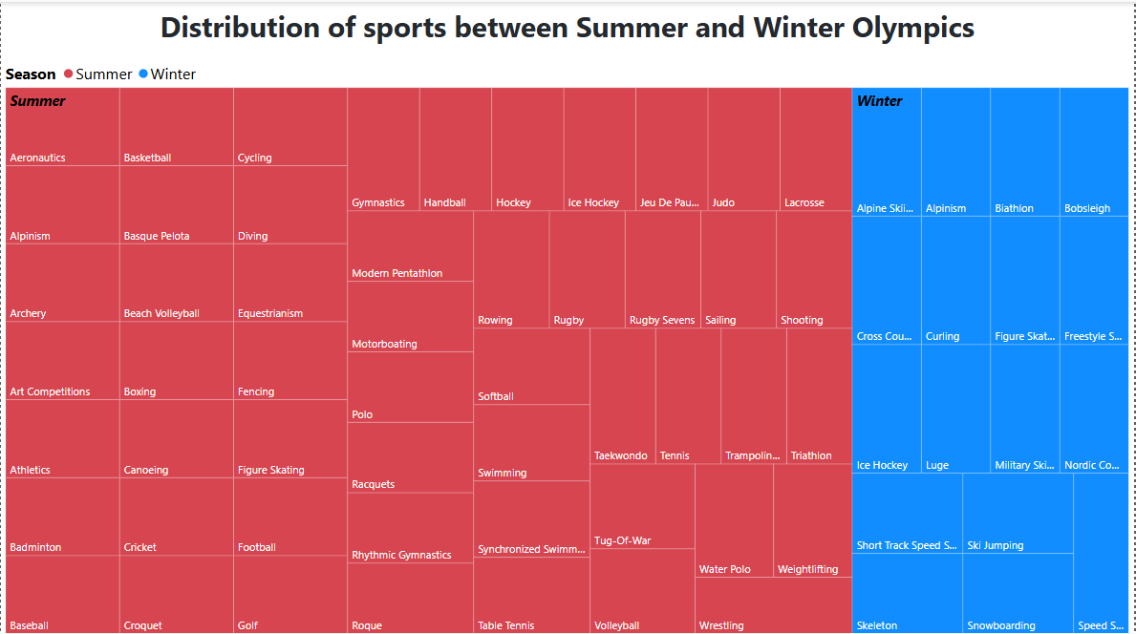
The Tree Map indicates that the Summer Olympics feature a significantly broader range of sports than the Winter Olympics, emphasizing the wider appeal and accessibility of summer sports. Disciplines such as athletics, swimming, and gymnastics enjoy extensive global participation, contributing to the diversity of the Summer Games.
In contrast, the Winter Olympics are confined to sports suited for colder climates, such as skiing, ice hockey, and figure skating. This limited range is a result of geographical and climatic constraints that restrict year-round training and infrastructure. The contrast in variety also affects the number of participating nations, with the Summer Games generally drawing more countries and athletes.
- Which sports have the highest number of events in the Olympics?
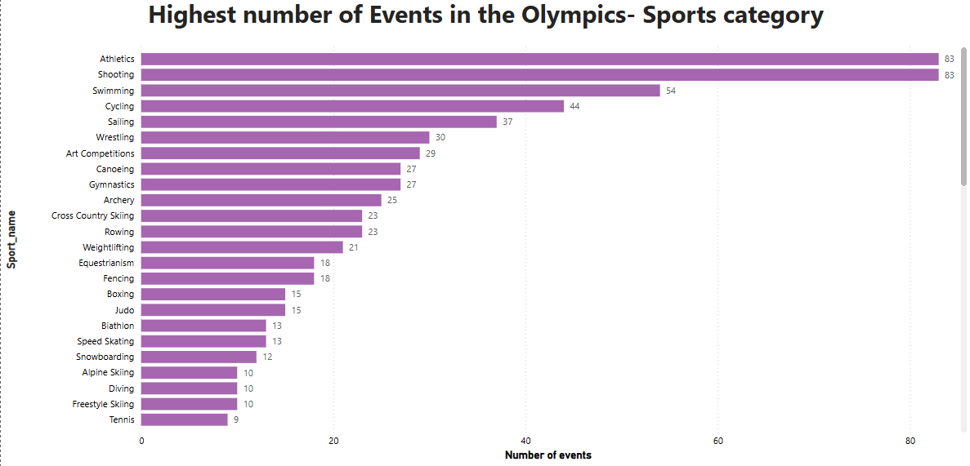
This Clustered Bar Chart analysis shows that athletics and swimming have the highest number of sports played in the Olympics. While sports like Alpinism, Baseball, Cricket, Rugby, Softball, Tug-Of-War, Polo, Roque have been played just once.
- How has the participation in each sport evolved over time?
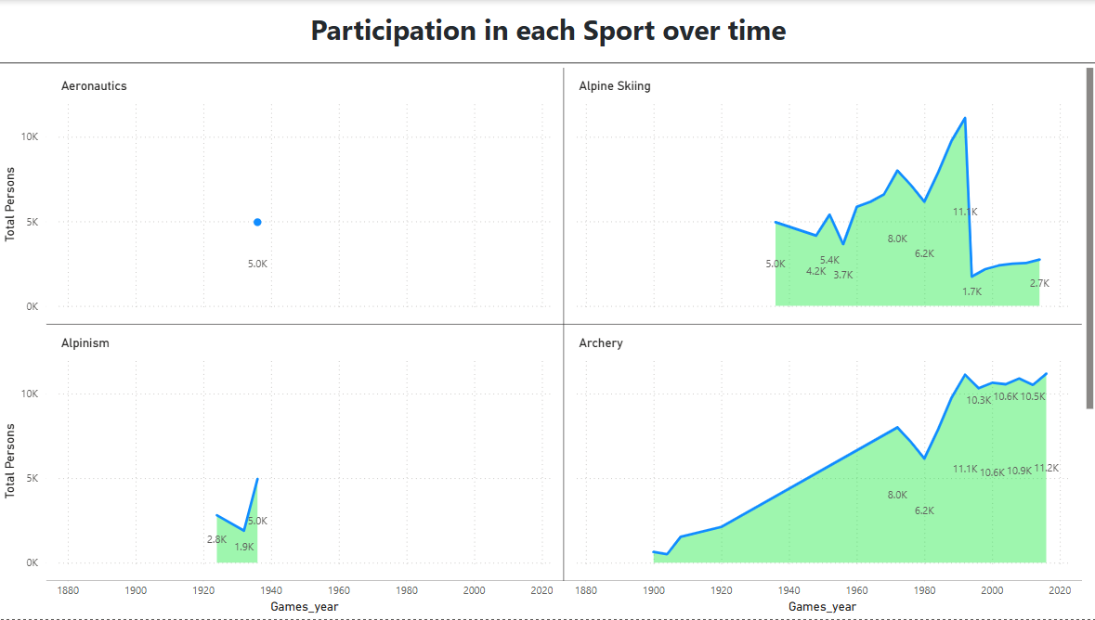
This multiple Stacked Area Chart indicates that participation in most sports has increased over time, reflecting the Olympics’ growing global reach and the introduction of more inclusive policies. All sports have seen steady growth.
This increasing trend highlights both the expanding diversity of the Games and the rising interest in a broader range of disciplines worldwide.
- How many events are there in each sport?
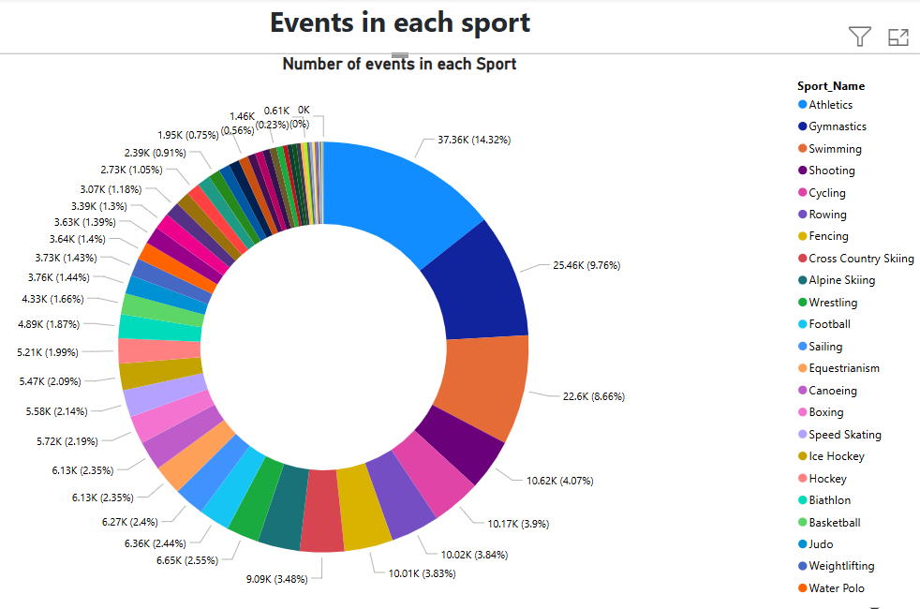
The Donut Chart shows that the number of events varies significantly across sports, with disciplines like Athletics (14.32%), Gymnastics (9.76%) and swimming (8.66%) as Top3. This reflects their diverse formats and categories, such as different distances, apparatus, or styles. In contrast, newer or niche sports tend to have fewer events, contributing less to the overall medal tally.
- What is the distribution of events by gender (Men, Women, Mixed)?
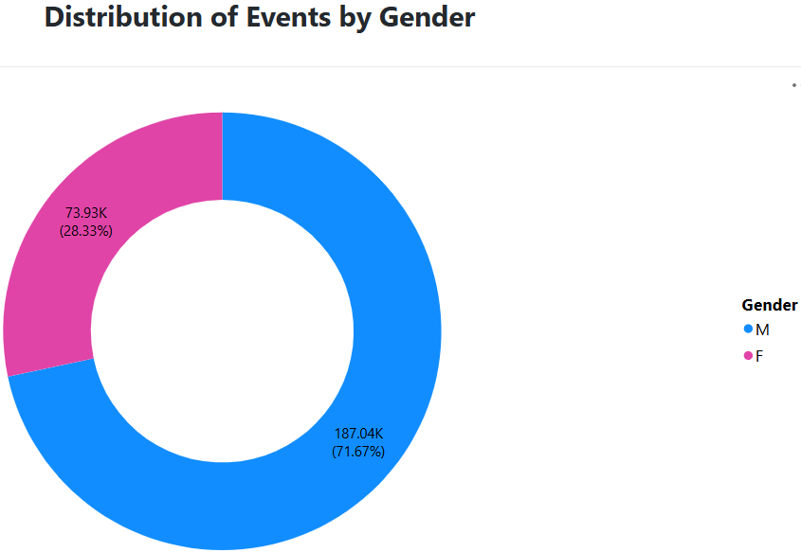
The distribution of events by gender reveals a strong move toward gender parity over time in the Olympics. While men’s events historically dominated, the number of women’s has steadily increased, especially in recent editions.
While no data was found for Mixed gender, we may see it in the future games.
- How has the number of events changed over time?
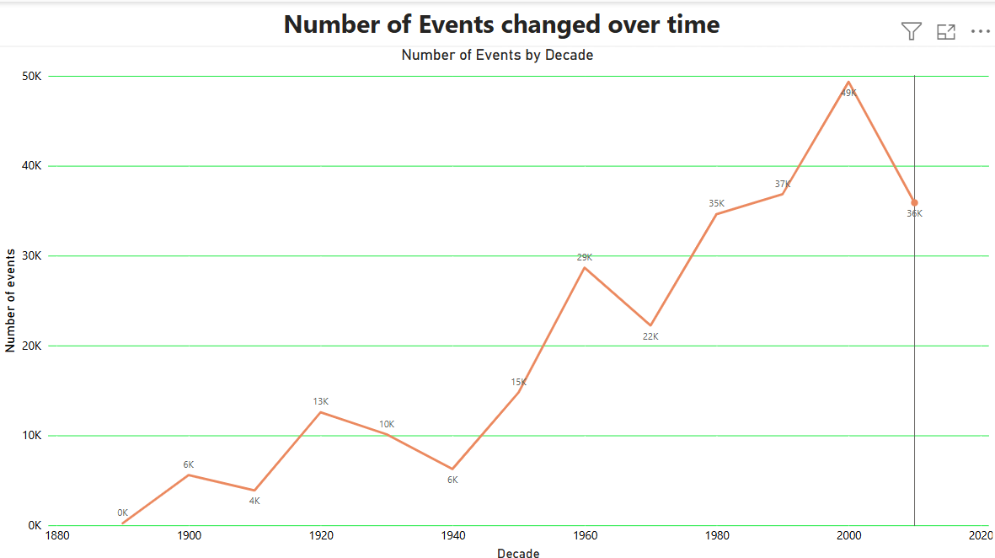
The Line Chart representation detects that the number of Olympic events has steadily increased over time, owing to the addition of new sports and disciplines. Major growth periods align with the introduction of women’s and mixed events, as well as the addition of modern and youth-oriented sports.
This evolution highlights the Olympics’ adaptability to changing global interests and its commitment to inclusivity and diversity.
- What is the distribution of participants by gender?
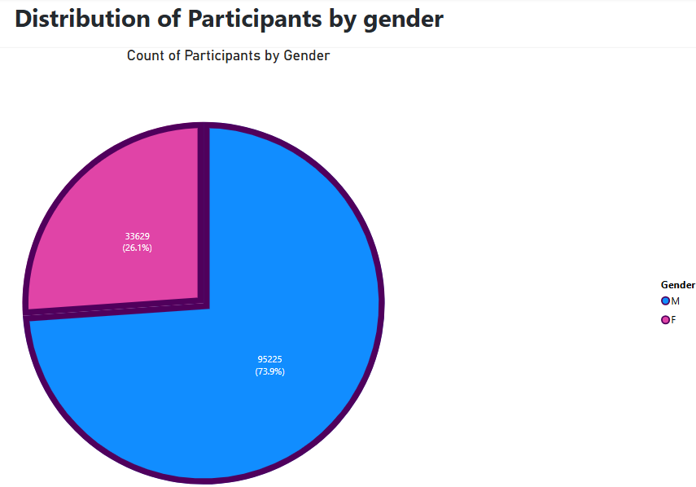
The pie-chart states that male participants consistently and historically outnumbered females, the gender gap has narrowed significantly in recent decades. Recent Olympic editions demonstrate a strong shift toward gender-balanced participation, driven by global advocacy for gender equality and promote equal representation across events.
- Which countries have the highest number of participants in the Olympics?
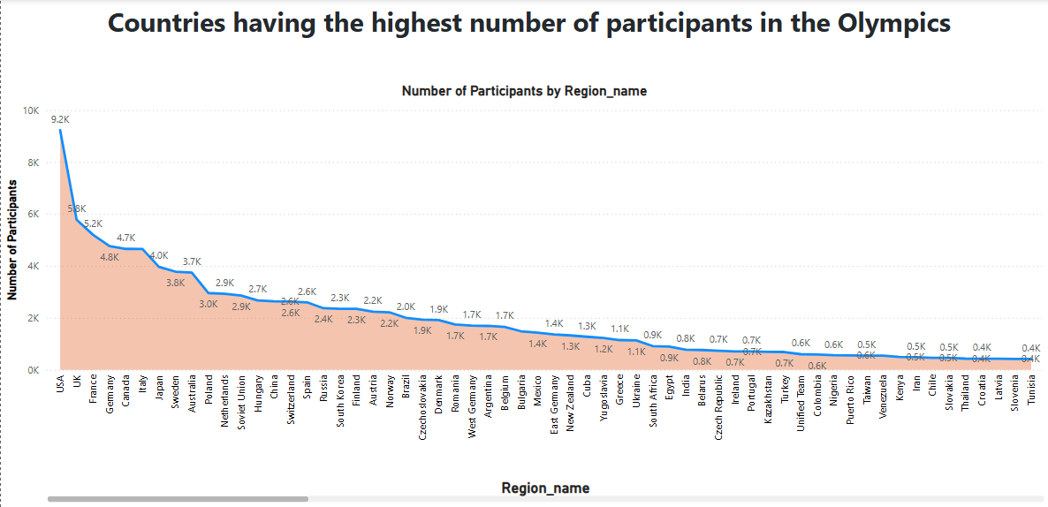
The Area Chart mentions that United States has the highest participation record of 9225, followed by United Kingdom – 5783.This can be largely clarified by their significant populations, advanced sports infrastructure, and a long-term commitment to fostering athletic talent.
The chart also reveals countries like Somania, Yemen, Qatar, Nepal among others that have hardly 1 person participating. Hopefully we may witness high participation from them in the coming years.

- How does the age distribution of participants vary across different games?
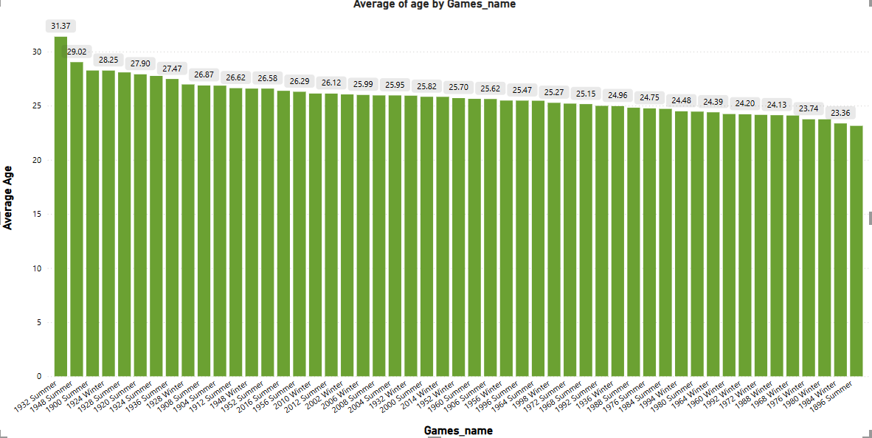
The Clustered Column Chart age distribution of Olympic participants varies across different Games, showing a wide range of mix of young and experienced athletes. However, in recent editions, there's a slight trend toward younger average ages.
The age of the participants ranges from 10 to 97. The oldest person - John Quincy Adams Ward -97years old participated in 1928 summer Olympics, and the youngest one – Dimitrios Loundras -10yrs old participated in 1896 Summer.
- How many medals have been awarded in each Olympics?
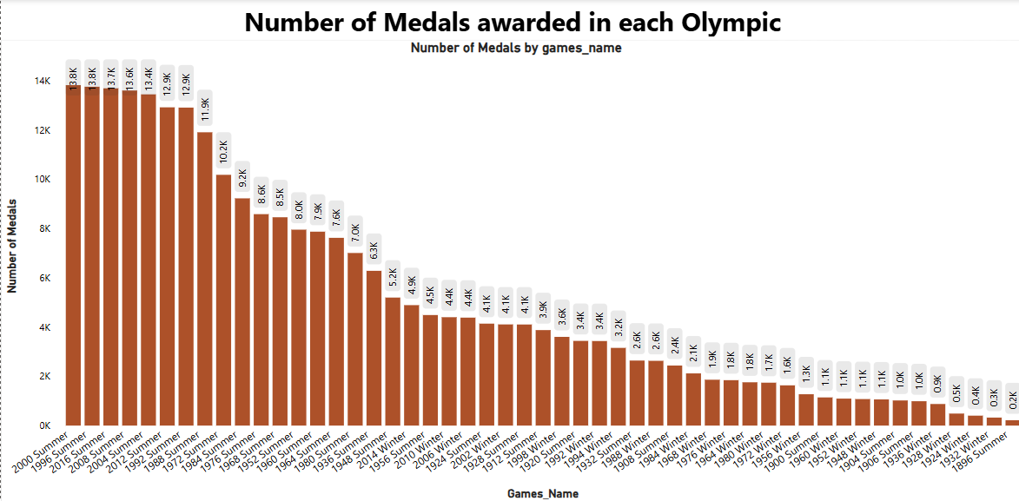
From this Clustered Column chart- The number of medals awarded has steadily increased over the years, with recent Summer Olympics (2008–2016) awarding the highest number of medals — over 13,815 per edition.
The 1996 Summer Olympics awarded the highest number of medals (13,750), followed closely by 2016 and 2008, indicating a period of maximum Olympic scale and participation.
- Which countries have the highest number of gold medals?
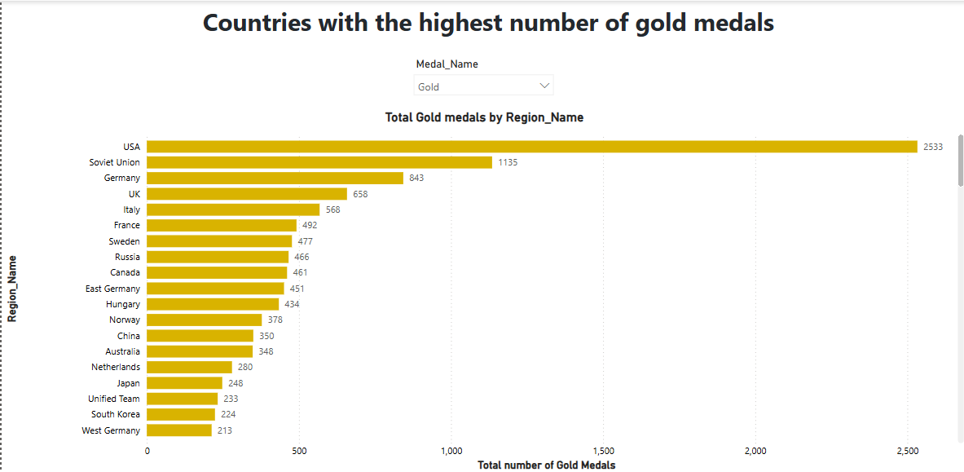
This Clustered bar chart clearly guides that the USA is the most successful Olympic nation in terms of gold medals. Historical powers like the Soviet Union and Germany also showcase strong performances.
Additionally, the rise of Asian countries such as China and Japan indicates a geographical shift in Olympic dominance, suggesting a more competitive and globally balanced sporting future.
- How does the medal distribution vary across different sports?
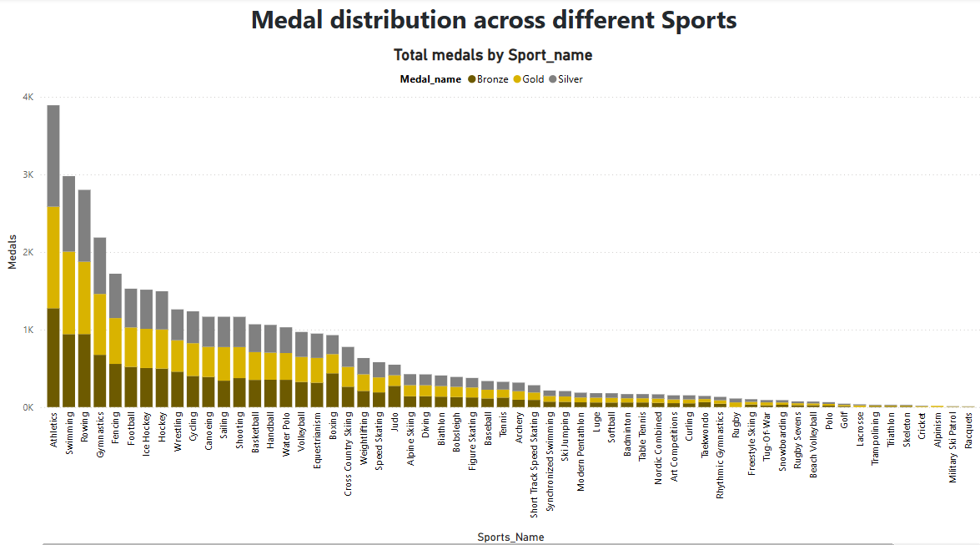
According to the Stacked Column Chart, Athletics, Swimming, and Gymnastics are the predominant sports in terms of Olympic medal allocation, primarily because of the numerous events held in these areas.
Additionally, team sports and established winter sports contribute meaningfully to the overall medal tally. Conversely, some less common or historical sports demonstrate minimal medal presence, reflecting the transformation of the Olympic sports selection over the years.
- How many regions or NOCs participate in each Olympic Games?
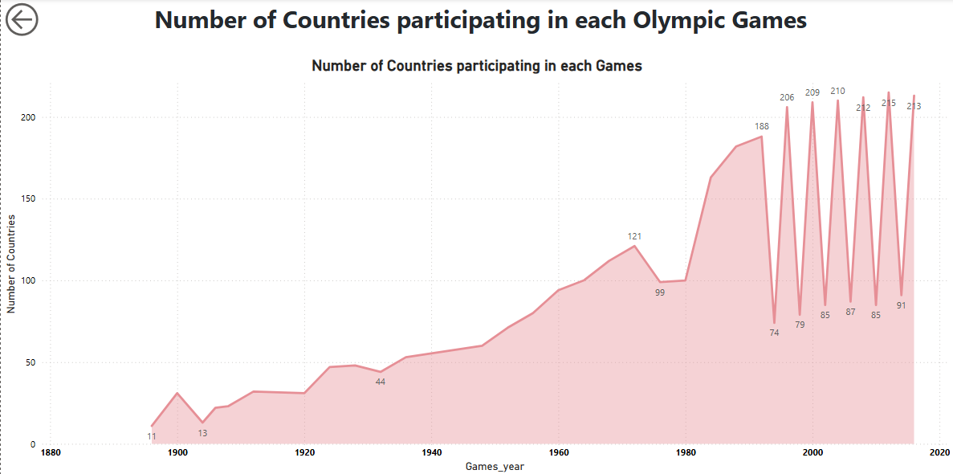
The Line Chart area reveals the rise and falls of countries participating in the Olympics over time.
The increasing number of countries participating highlights improved international cooperation, geopolitical shifts, and the Olympic movement's success in fostering inclusivity.
Although political conflicts briefly interrupted participation during the Cold War, the post-1990s era demonstrates sustained, high engagement from nations worldwide, reflecting a strong and unified international sporting spirit.
- Which regions have the highest number of participants in the Olympics?
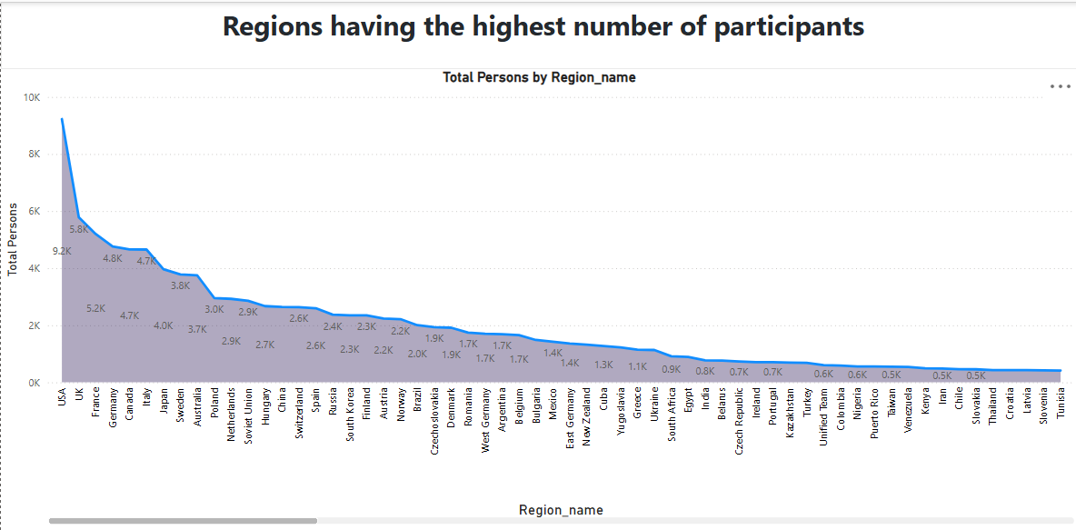
The Stacked Area Chart analysis of participant distribution emphasizes that developed nations, equipped with rich Olympic traditions, dominate in athlete representation.
The USA is particularly prominent, reflecting a substantial lead owing to its deep investment in a wide array of sports. The gradual decline in participation figures illustrates the uneven global representation in the Olympics, shaped by economic capabilities, access to training, and historical presence.
- What is the distribution of medals among different regions?
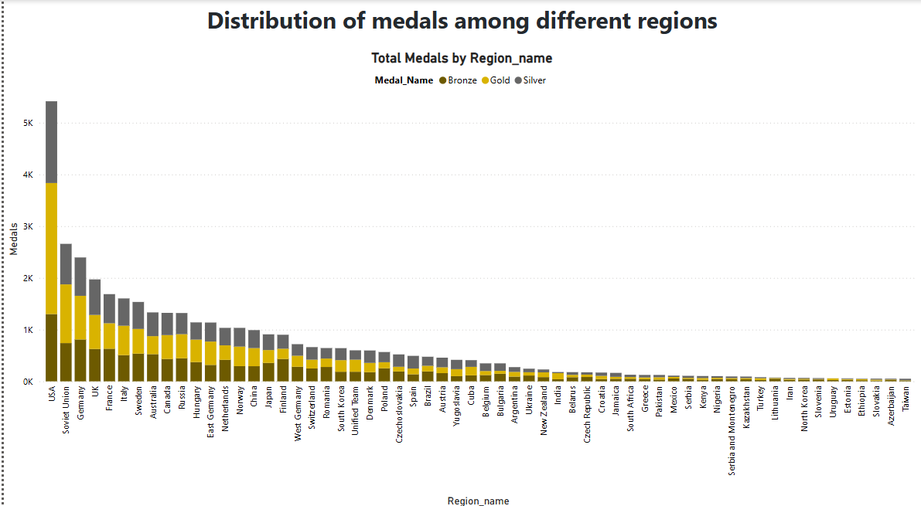
The allocation of medals reveals a distinct pre-eminence of a select few historically dominant nations, notably the USA, which has reliably surpassed other nations in performance. The involvement of countries like the Soviet Union and Germany, recognized for their significant medal totals, also highlights the role of historical and political contexts in shaping Olympic success.
EDA PROBLEMS
STATEMENTS
- Are there any trends or patterns in the frequency of hosting Olympic Games?
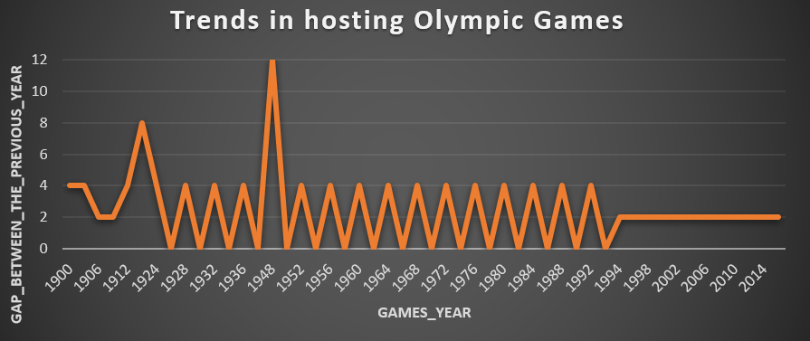
The line chart plots the gap between Olympic Games years from 1900 to 2014. A noticeable 8-year gap between 1912 and 1920 due to World War I. 1940 and 1944 Games were skipped, leading to a 12-year gap between 1936 and 1948 due to World War II.
After 1994, the gap has consistently been 2 years, showing strong institutional regularity and better global coordination.
- How has the duration of Olympic Games changed over time?
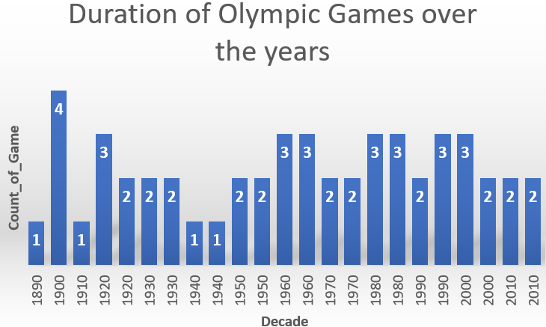
The bar chart displays the number of Olympic Games held per decade from the 1890s to the 2010s. The 1900s witnessed 4 Olympic Games, indicating experimentation or overlap between seasonal formats. Only 1 event each in the 1890s and 1910s, maybe because of early phase of the Olympics and World War I.
The 1940s had only 1 event, disrupted by World War II. The 1960s–1980s maintained 3 events per decade, aligning with both Summer and Winter Olympics. Post 1990 show a consistent 2–3 Games per decade, reflecting institutional robustness and global coordination.
- Are there any notable events or occurrences associated with specific Olympic Games?
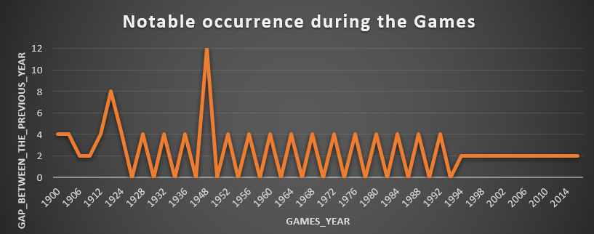
Yes, the line chart prominently showcases various key events or occurrences associated with certain Olympic Games, especially concerning disruptions in their regular hosting pattern. The most striking instances are the large intervals between games, which are directly linked to:
a) The 8-year interval that preceded the 1920 Games, which signifies the cancellation of the 1916 Olympics due to World War I.
b) The even more significant 12-year interval leading up to the 1948 Games, which indicates the cancellation of both the 1940 and 1944 Olympics as a result of World War II.
- Are there any emerging sports that have been recently added to the Olympics?
The chart below lists 10 sports introduced to the Olympic program between 1992 and 2016.

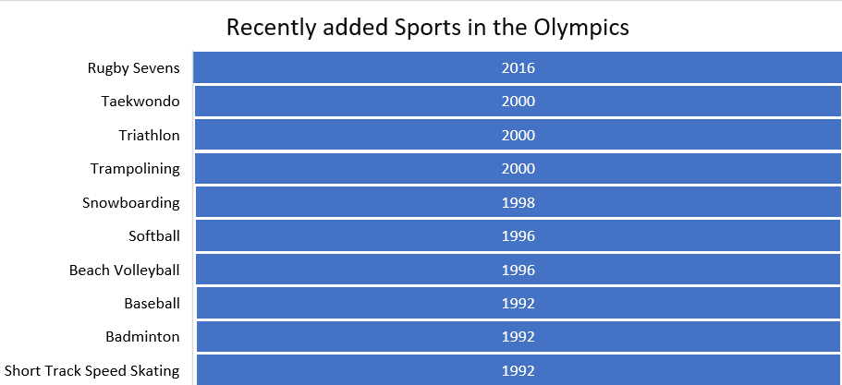
The Olympic Games have strategically expanded their sports portfolio to include emerging, fast-paced, and youth-oriented events.
The continuous inclusion of sports since 1992 indicates an evolving, inclusive Olympic spirit that welcomes modernity while respecting tradition. Future editions of the Games are likely to see further innovation with sports influenced by urban culture, digital trends, and global popularity.
- How has the popularity of certain sports changed over the years?
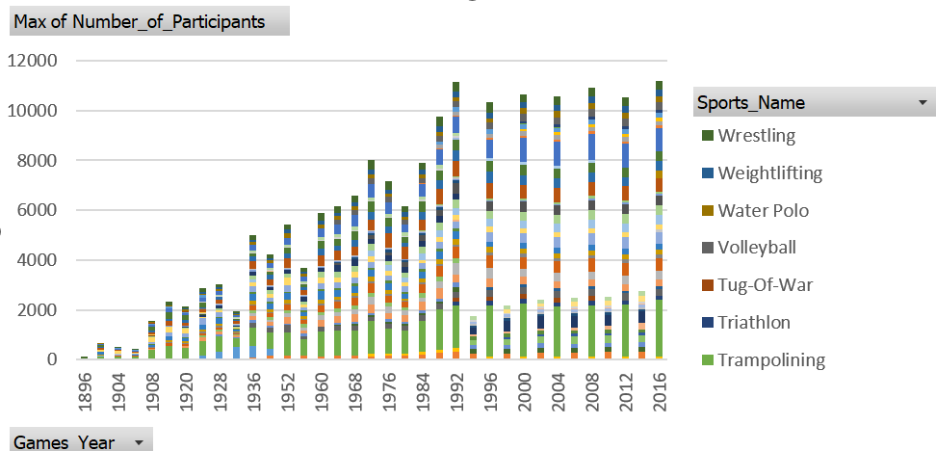
This stacked bar chart visualizes the number of participants across selected sports from 1896 to 2016. From less than 500 participants in 1986 to crossing 10,000 in recent years - indicates increased global representation and expanding sport rosters.
The most dramatic increase in participation occurs post-1980, reflecting the globalization of the Olympics and entry of new nations and athletes post-Cold War.
The data highlights a broader narrative of inclusivity, modernization, and an increasing global enthusiasm for the Olympic movement.
- Are there any sports that are specific to a particular region or culture?
Yes — sports such as Cricket, Jeu De Paume, Racquets, and Motorboating have only been played by athletes from the UK, suggesting strong regional or cultural ties.
- Are there any sports that have a higher number of events for one gender compared to others?
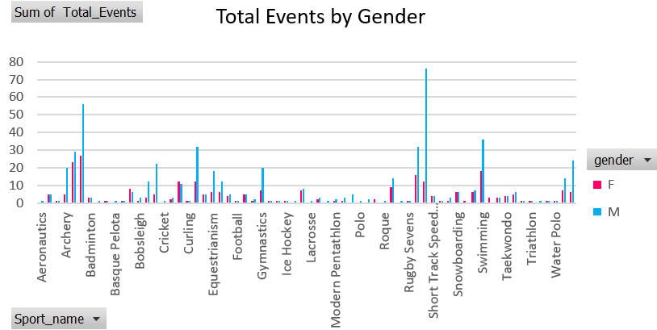
This bar chart compares the total number of events for male (M) and female (F) athletes in each Olympic sport. The pink bars represent female events, and the blue bars represent male events, giving a visual cue to detect disparities in gender representation across various disciplines.
Male-Dominated Sports: Shooting, Athletics, Sailing
Female-Dominated Sports: Art-Competitions, Swimming, Cross-country Skiing
- Are there any new events that have been introduced in recent editions of the Olympics?
This horizontal bar chart below showcases the timeline of new Olympic events introduced since the 2000.

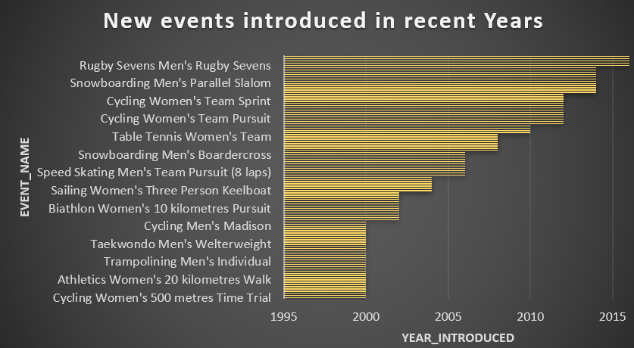
The Olympics has adopted a strategic way to adapt over time—adding gender-diverse, fast-paced, and globally popular events. The growing focus on women’s participation, the introduction of new team events, and the rise of high-energy sports highlights the Games’ commitment to inclusion, variety, and modernization.

- Are there any events that have been discontinued or removed from the Olympics?
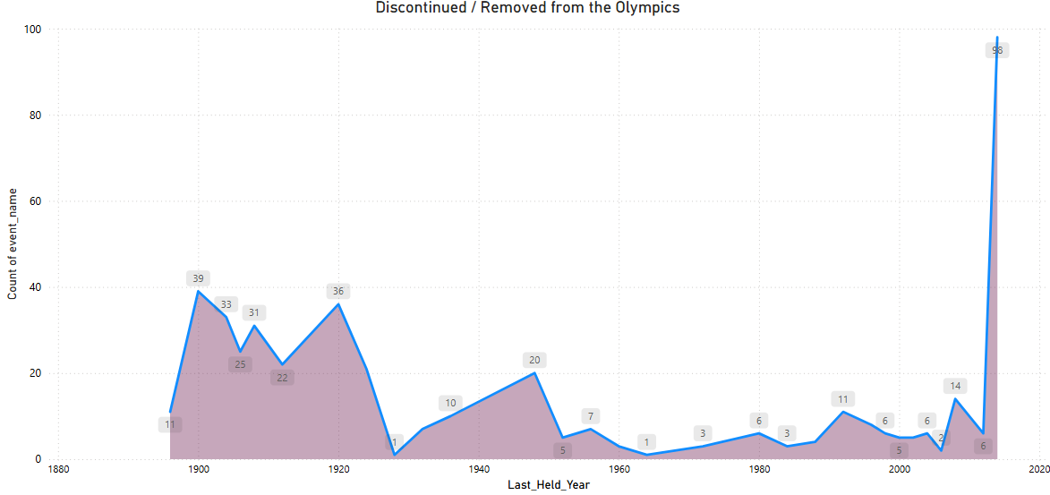
This line graph exhibits the number of Olympic events that were last held. Highest spike was in 1900 (39 events). A few events were discontinued after WWII and into the 1960s, possibly due to global restructuring of sports policies and geopolitical changes.
Sudden surge in 2020 (98 discontinued events) marks a significant reshaping of the Olympic program. This may be due to pandemic-related disruptions.
- Are there any notable trends in the height and weight of participants over time?
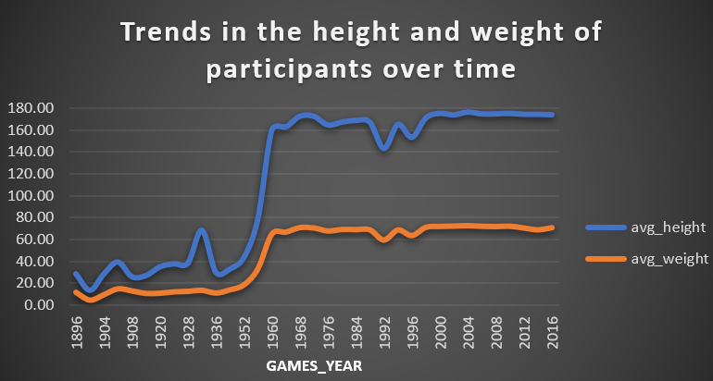
This line chart demonstrates the average height and weight of Olympic participants across various Games years, from 1896 to 2016. In early years both height and weight showed irregular and relatively low values in the early years. A sharp increase in average height (from ~40 cm to over 160 cm) and weight (~15 kg to 60 kg) was observed around the 1952 Games. This increase may owe to athletic conditioning standards.
Since the 1960s, these metrics have stabilized, suggesting that a balance has been reached between athlete physique and sport specialization. This reflects the maturation of the physical profiles of Olympic athletes in accordance with modern performance standards.
- Are there any dominant countries or regions in specific sports or events?
This sunburst chart shows country-wise dominance in various Olympic sports, based on the medals won. United Kingdom (UK) was highly dominant in multiple sports owing to Athletics with 2,196 achievements — the largest share.
Repeated UK entries across many segments indicate consistent overall dominance. Other outer segments show a broad spread of countries with smaller slices, suggesting a high level of international competitiveness in many sports. While a select few nations are at the forefront, many countries participate competitively, reflecting the worldwide and inclusive character of the Olympic Games.
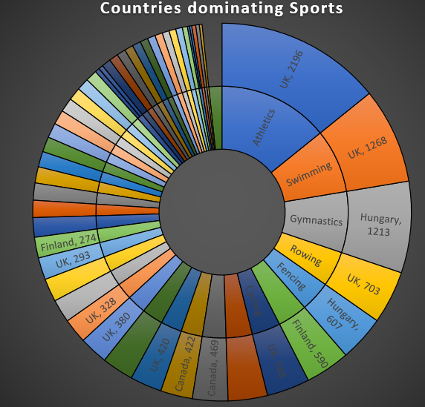

- What factors contribute to the success or performance of participants from different countries?
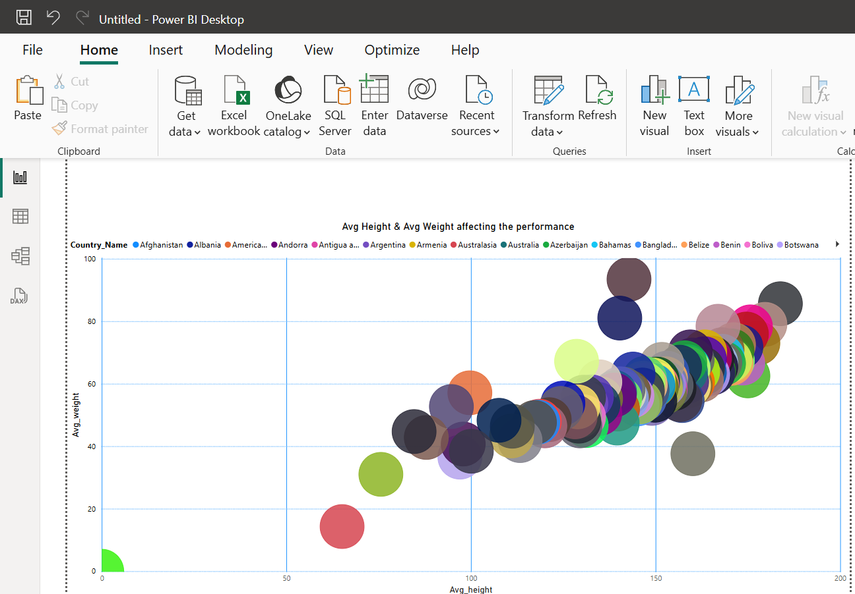
The chart visualizes the relationship between the average height (x-axis) and average weight (y-axis) of participants, grouped by country. Each bubble represents a country, and while the size of the bubble isn't explicitly defined by a legend.
The most apparent observation from the chart is a positive correlation between average height and average weight across different countries. As the average height of participants from a country increases, their average weight also tends to increase. This is a natural physiological correlation.
- Are there any countries that consistently perform well in multiple Olympic editions?
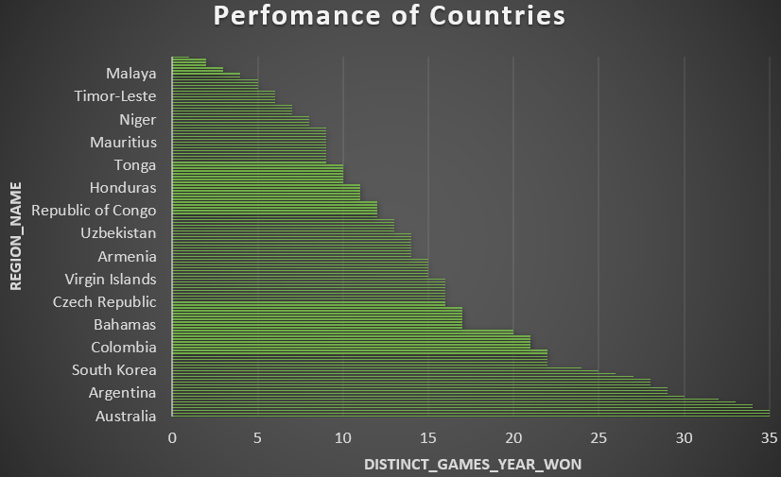
Based on this bar chart we can analyze the consistency of countries performance across Olympic editions.
Australia, Greece and UK are the highest performer, 35 distinct games years won. This suggests a very high level of consistency and sustained success over a long period. Meanwhile, Hungary & Canada follows them, with 34 distinct wins.
Countries like Marshall Islands, Tuvalu, North Yemen, South Sudan and Zimbabwe (Rhodesia) are at the lower end of the spectrum, with fewer distinct games years won (less than 3).
- Are there any sports or events that have a higher number of medalists from a specific region?
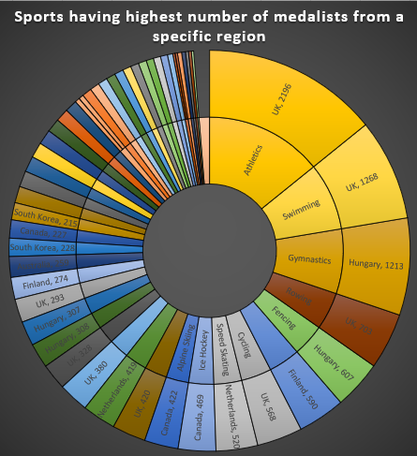
From this donut chart we can identify sports where a specific country has a notably higher number of medalists.
The largest segment by far is Athletics, where the UK has the highest number of medalists, with a count of 2,196. Following Athletics, Swimming also shows the UK as having the highest number of medalists, with 1,268. This reinforces the UK's strength in major Olympic sports.
- What are some notable instances of unexpected or surprising medal wins?
The UK's medal count of 11,536 is exceptionally high, which denotes its status as a major historical Olympic power. This is expected from a nation with a long and rich sporting history.
South Sudan is a relatively new nation, having gained independence in 2011. For such a nation to have accumulated 4 medals suggests a remarkable achievement. North Borneo's Medal Wins (2 medals): North Borneo refers to the former British colony, which is now part of Malaysia (Sabah).
- Are there any regions that have experienced significant growth or decline in Olympic participation?
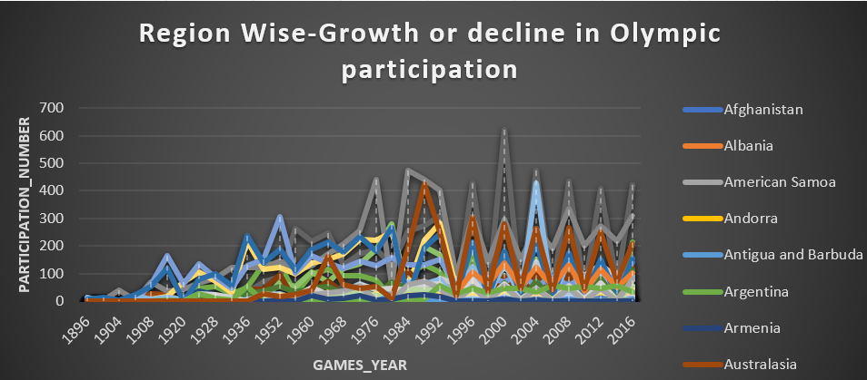
This line chart reveals significant growth trends in Olympic participation for several countries.
Many countries, even those with relatively low participation, show an overall upward trend in participation numbers over the long term, albeit with fluctuations. This could reflect the overall growth of the Olympic movement and increased global participation over the decades.
- How do cultural or geographical factors influence the performance of regions in specific sports?
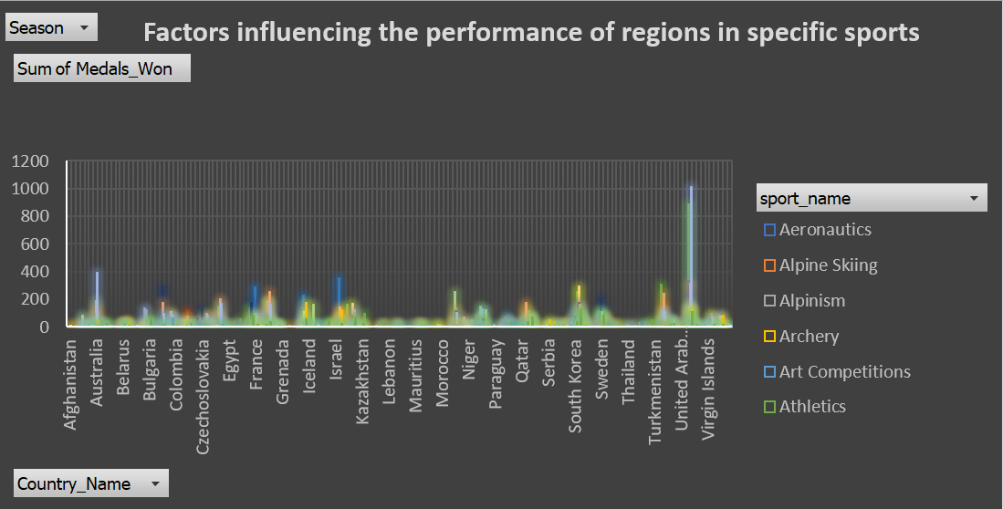
This histogram highlights key patterns of regional dominance shaped by cultural traditions and geographic conditions.
Winter-dominated sports like Ice Hockey, Cross Country Skiing and Alpinism have participants from countries like Canada, Sweden, Iceland, and Soviet Union. These sports that are naturally suited to their mountainous or snowy terrains.
Summer-dominated sports like Swimming, Fencing, Rowing, Athletics have participants from Australia, USA and UK.
The data indicates that geographical advantages, such as cold climates or mountainous regions, significantly boost performance in winter or terrain-specific sports. In addition, cultural emphasis, government support, and a rich sporting history are essential components of broader success. Regions are likely to excel in sports that align with their natural environment and cultural values, thus confirming the impact of both culture and geography on sports performance.
- Are there any regions that have had a notable impact on the overall medal tally?
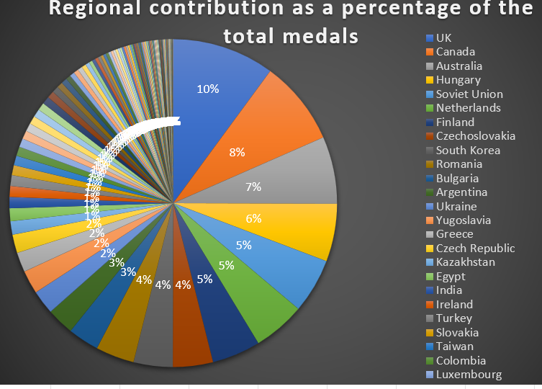
This Pie chart displays the percentage contribution of various regions to the total number of medals.
With 10% of the total medals, the UK stands out as the single largest contributor (nearly 10%) among the regions shown. This indicates a very significant and notable impact on the overall medal tally. Following the UK, Canada accounts for 8% of the total medals, making it another major contributor.
As the segments get smaller, the percentage contribution decreases. Many regions contribute 3%, 2%, or 1%, with a large number of regions contributing less than 1% (represented by the very thin slices on the left side of the chart, often grouped as "others" or simply too small to label individually).

CONCLUSION
The in-depth analysis of the Olympic Games dataset has provided crucial insights into the evolution, diversity, and dynamics of sports worldwide over time. By exploring data across various dimensions—such as Games, Sports, Athletes, Participation Trends, and Medals—this project highlights the complex nature of the Olympics and its socio-cultural importance globally.
From a Games viewpoint, we have observed the consistency and expansion of the Olympics, with marked differences between the Summer and Winter editions regarding their frequency and scale. As time has gone on, the number of events hosted and the regions participating has grown, illustrating increased global engagement and the unifying power of sports.
In the field of Sports, the analysis uncovered that the variety of disciplines has grown, with new sports emerging and some being discontinued over the decades. Athletics and Swimming, for instance, continue to be fundamental to the Olympic spirit, attributed to their large number of events and extensive participation.
Athlete evaluations demonstrated discrepancies in physical attributes like height, weight, and age across various editions. Such changes suggest a transformation in the standards of athleticism, progress in training techniques, and enhanced global access to professional sports. Furthermore, gender participation has made significant progress, as the growing representation of females indicates movement towards equality in international sports.
Trends in participation indicate an increase in inclusivity, with a greater number of regions and countries joining the Olympic arena. Certain nations have demonstrated steady strength in participant numbers, whereas others show significant growth, especially from under-developed areas. This pattern reflects not only advancements in athletics but also an increase in global investment in sports infrastructure and talent cultivation.
Lastly, the medal distribution revealed some surprising outcomes- third world countries occasionally exceeded anticipated results, showcasing the inherent unpredictability and excitement of the Olympic Games.
In conclusion, the analysis of this Olympic dataset provides a profound narrative of worldwide competition, sports diversity, cultural exchange, and world-peace achievement by promoting understanding and cooperation through sport.

